BUSINESS INTELLIGENCE
ETL AND DATA WAREHOUSE DESIGN USING KAGGLE RETAIL DATASET (Northwind Traders)
Supervisor:
Endah Septa Sintiya, S.Pd., M.Kom.

Disusun oleh:

Antonius Kaharap Kautsar 2341720067
Charellino Kalingga S 2341720205
Erwan Majid 2341720064
Hammam Abdullah S B G 2341720203
Ridho Anfa’al 2341720222

INFORMATION TECHNOLOGY DEPARTMENT
DIPLOMA IV IN INFORMATICS ENGINEERING STUDY PROGRAM
MALANG STATE POLYTECHNIC
Github Link : https://github.com/hemoabdullah/Business-Intelligence
Visualisation Link: https://lookerstudio.google.com/embed/reporting/8e31d809-6197-4d02-9c40-740f3b93aa3b/page/KsRiF
Table of Contents

Table of Contents 1
CHAPTER 1
INTRODUCTION 3
1.1 Background 3
1.2 Problem Statement 3
1.3 Project Objectives 3
1.4 Scope of Problem 3
1.5 Project Benefits 4
CHAPTER 2
CASE STUDY AND DATA DESCRIPTION 5
2.1 Case Study Selection 5
2.2 General Description of Case Study 5
2.3 Dataset Source 5
2.4 Dataset Structure 5
2.5 Reasons for Case Study Selection 6
CHAPTER 3
DATA WAREHOUSE DESIGN (STAR SCHEMA) 7
3.1 Identification of Fact Tables 7
3.2 Dimension Table Identification 7
3.4 Diagram Star Schema 8
3.5 Inter-Table Relationships (Relational Mapping) 8
CHAPTER 4
ETL PROCESS DESIGN 9
4.1 General Overview of ETL 9
4.2 The ETL Job Orchestration 9
4.3 Transformation Phase Details 9
4.3.1 Data Cleaning 9
4.3.2 Data Transformation 9
4.3.3 Data Aggregation 10
4.3.4 Data Integration 10
CHAPTER 5
ETL PIPELINE IMPLEMENTATION 11
5.1 Software Architecture 11
5.1.1 Software Architecture 11
5.1.2 Database Connection Configuration 11
5.2 Implementation of Dimensional Transformation 12
5.2.1 ETL_Employee 12
5.2.2 ETL_Customers 14
5.2.3 ETL_Categories 15
5.2.4 ETL_Date 17
5.3 Implementation of Fact Transformation 20
5.4 ETL and Main Job Execution 25
5.5 Results and Validation 26
CHAPTER 6 27
ANALYSIS AND VISUALIZATION 27
6.1 Final Data Warehouse 27
6.1.1 Dimension Table 27
6.1.2 Fact Tables 29
6.2 Sample Queries 29
6.3 KPI Calculation 31
Combined SQL Query (All KPIs in One Query) 32
6.4 Dashboard Visualization 33
6.4.1 Sales Overview 33
6.4.2 Top Products & Category Performance 34
6.4.3 Product portfolio: volume vs revenue 36
6.5 Analysis of Findings 37
CHAPTER 7
CONCLUSION AND SUGGESTIONS 38
7.1 Conclusion 38
7.2 Suggestions 38

CHAPTER 1
INTRODUCTION

1.1 Background
A company's strategic decision-making relies heavily on data. Northwind Traders (a fictional company) wants to implement a Data Warehouse (DW) to analyze its transaction processes, specifically to calculate Key Performance Indicators (KPIs) such as revenue.

Northwind Traders operational data (OLTP) is often scattered across various systems and unstructured for comprehensive analysis. Therefore, an Extract, Transform, and Load (ETL) process is required to integrate the raw data into a centralized, organized structure.

This project uses the AdventureWorks Retail Kaggle dataset, which contains sales, product, customer, and region data. This dataset will be processed through an ETL process using MySQL to produce a Star Schema model ready to support business analysis and KPI visualization.

1.2 Problem Statement
The problem statement in this project is as follows:
- How to design a Star Schema consisting of fact tables and dimension tables to represent Northwind sales data?
- How is the ETL process applied to integrate raw CSV data (orders, order_details, products)?
- How to perform analysis to calculate KPIs like Total Sales and Top Selling Products?

1.3 Project Objectives
The objectives of this project are:
- Design a star schema based on the Northwind dataset.
- Build an ETL pipeline to extract, transform, and load clean data.
- Produce a Data Warehouse structure ready for sales KPI analysis

1.4 Scope of Problem
The scope of the project includes:
- The dataset used includes the uploaded CSV files: orders, order_details, products, categories, customers, employees, and shippers.
- Analysis focuses on sales data and supporting dimensions (customer, product, time).
- Tools ETL yang digunakan adalah Pentaho Data Integration (PDI).
- Data warehouse dibangun menggunakan skema bintang sederhana

1.5 Project Benefits
The benefits obtained include:
- Understanding how to integrate various data sources into a single analysis model.
- Developing the ability to design star schemas based on business needs.
- Improving skills in performing ETL using professional tools.
- Producing a data warehouse that can support analysis and decision making.
- Providing a basis for creating sales KPI dashboards.

CHAPTER 2
CASE STUDY AND DATA DESCRIPTION

2.1 Case Study Selection
The Northwind Traders dataset was selected as the case study because it represents a classic relational database scenario widely used in database literature. It offers a perfect balance of complexity—containing typical ERP (Enterprise Resource Planning) entities like employees, customers, orders, and suppliers—making it an ideal candidate for demonstrating ETL principles and Data Warehouse design

2.2 General Description of Case Study
Northwind Traders is a fictional company that manages orders for specialty foods from around the world. The workflow involves:
- Customers placing Orders.
- Orders containing multiple Line Items (Order Details).
- Products belonging to specific Categories (e.g., Beverages, Condiments).
- Employees facilitating these transactions. The goal is to transform this transactional flow into an analytical model to answer questions like "Who is the most profitable customer?" or "Which category drives the most revenue in Q4?"

2.3 Dataset Source
- Source: Kaggle - Northwind Traders
- URL: https://www.kaggle.com/datasets/jeetahirwar/northwind-traders
- Format: CSV (Comma Separated Values)

2.4 Dataset Structure
Summary of the dataset structure used in this project:

File Name (Table) | Main Columns | Description
orders.csv | orderID, customerID, employeeID, orderDate, freight | Records transaction headers and dates.
order_details.csv | orderID, productID, unitPrice, quantity, discount | Records transaction details (items sold).
products.csv | productID, productName, categoryID, unitPrice | Stores complete information about every product.
categories.csv | categoryID, categoryName, description | List of main product categories.
customers.csv | customerID, companyName, contactName, country | Stores customer demographic profiles.
employees.csv | employeeID, lastName, firstName, title | Stores information about the employees handling orders.

2.5 Reasons for Case Study Selection
This dataset was chosen because:
- Referential Integrity: The dataset maintains strong consistency between Foreign Keys (e.g., all productIDs in order_details exist in products), ensuring a smooth Join process.
- Rich Dimensionality: It allows for slicing data by multiple dimensions: Time (OrderDate), Geography (Customer Country), and Product Hierarchy (Category).
- Calculated Metrics: It requires data transformation to derive actual sales values (Unit Price × Quantity - Discount), which is a core ETL task.

CHAPTER 3
DATA WAREHOUSE DESIGN (STAR SCHEMA)

3.1 Identification of Fact Tables
The main focus is Fact Sales to analyze revenue.

Fact Table | Source | Measurement Metrics | Foreign Keys
Fact Sales | Join of orders & order_details | quantity, unitPrice, discount, LineSales (Calculated) | productID, customerID, employeeID, orderDate

3.2 Dimension Table Identification
Dimension tables provide the "context" for the facts. We denormalized the raw data into four primary dimensions:
- Dim_Product: Created by joining products and categories. This allows analysis at both the Product level (e.g., "Chai") and Category level (e.g., "Beverages").
- Dim_Customer: Contains companyName, contactName, city, country. Useful for regional sales analysis.
- Dim_Employee: Contains firstName, lastName, title. Used to evaluate staff performance.
- Dim_Time: Derived from orderDate. Attributes include Year, Month, Quarter, DayOfWeek. Essential for time-series analysis.

3.3 Main Dataset Structure for Star Schem
Here is a summary of the data that will be mapped into the Star Schema:
File Name (Table) | Main Column Contents | Role in Star Schema
Adventure Works Sales 2015-2017 (Gabungan) | OrderDate, ProductKey, CustomerKey, TerritoryKey, Order Quantity, SalesAmount | Fact Sales (Tabel Fakta)
Adventure Works Products | ProductKey, ProductName, ProductCost, ProductPrice | Dim Product (Tabel Dimensi)
Adventure Works Customers | CustomerKey, FirstName, Gender, AnnualIncome | Dim Customer (Tabel Dimensi)
Adventure Works Territories | Sales TerritoryKey (dipetakan ke TerritoryKey), Region, Country, Continent | Dim Territory (Tabel Dimensi)
AdventureWorks Calendar | Date, MonthName, Year | Dim Date (Tabel Dimensi)

3.4 Diagram Star Schema
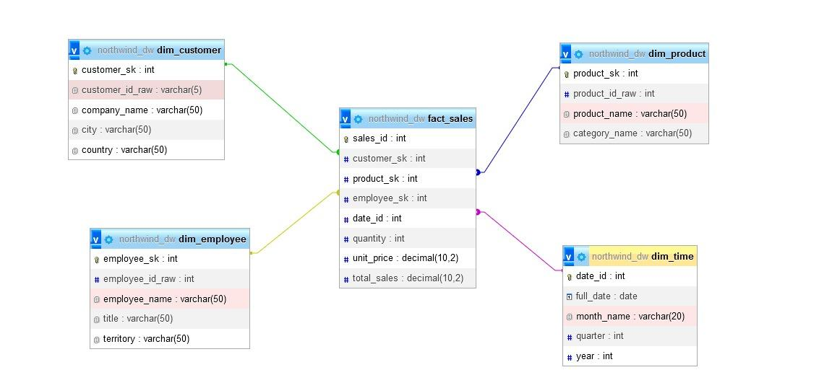

3.5 Inter-Table Relationships (Relational Mapping)
All Star Schema relationships between Dimensions and Facts are set as mandatory to ensure referential integrity and data quality in the Data Warehouse, ensuring that each revenue metric is connected to a valid context of Product, Customer, Region, and Time, in accordance with the requirements for filtering incomplete data at the ETL stage.

CHAPTER 4
ETL PROCESS DESIGN

4.1 General Overview of ETL
The ETL process is the core mechanism for populating the Data Warehouse. Using Pentaho Data Integration (PDI), the team implemented a coordinated Job (Job uas finish.kjb) that orchestrates five distinct Transformations (Transformation 1-5 uas.ktr). The process starts by ensuring the target tables are ready (SQL step), loads all dimension tables first, and finally loads the large fact table using the generated surrogate keys.

4.2 The ETL Job Orchestration
- The main job sequences the transformations to enforce dependencies:
Start & Initialization (SQL Step): Executes SQL to ensure the target DW tables are created or truncated, preparing the database (northwind_dw) for the load process.

- Load Dimensions (Transformation 1-4):
- Transformation 1 uas.ktr (Dim Employee)
- Transformation 2 uas.ktr (Dim Customer)
- Transformation 3 uas.ktr (Dim Product)
- Transformation 4 uas.ktr (Dim Time)

- Load Fact Table (Transformation 5):
Transformation 5 uas.ktr (Fact Sales) - This step relies entirely on the successful completion of the dimension loads to perform Surrogate Key Lookups.

4.3 Transformation Phase Details

4.3.1 Data Cleaning
- Source: Raw CSV files or OLTP staging tables.
- Cleaning/Type Conversion: Ensures data types match the DW schema (e.g., converting text-based dates to MySQL DATE type).
- Integration (Dim_Product): Joins the products and categories tables to create a single denormalized dimension entity.
- Key Generation: Assigns the auto-incrementing _sk (Surrogate Key) for each dimension record upon loading.

4.3.2 Data Transformation
The Transformation 5 uas.ktr is the most complex step, combining multiple sources and performing critical calculations:
- Data Source Integration: Joins the core transactional tables (orders and order_details).
- Surrogate Key Lookup: The original relational keys (customerID, productID, orderDate, etc.) are looked up against the newly loaded dimension tables (dim_customer, dim_product, dim_employee, dim_time) to retrieve the corresponding Surrogate Keys (_sk or date_id).
- Measure Calculation: Calculates the total_sales (revenue) for each line item using the formula:
Total Sales= Quantity x Unit Price x ( 1 - Discount )

4.3.3 Data Aggregation
This step is implemented using the Calculator step in Pentaho Data Integration (PDI). It transforms raw operational numbers into financial metrics that business users can aggregate (Sum/Count) later in their reports.
- Input Data: The process takes the raw columns from the order_details CSV:
  - Quantity (e.g., 10)
  - UnitPrice (e.g., $20.00)
  - Discount (e.g., 0.05 or 5%)

- The Transformation Logic: A formula is applied to every single row to determine the actual revenue generated by that specific line item.
  - Formula: Line Total = Quantity * UnitPrice * (1 - Discount)

- Output Data: A new field named total_sales is created.
  - Example Result: 10 * 20 * (1 - 0.05) = $190.00

- Why this is "Aggregation": While technically a row-level calculation, this step prepares the Atomic Data (lowest level of detail) so that the Data Warehouse can perform rapid aggregations (Summing total_sales by Year, by Country, or by Product) without having to recalculate the math for every query.

4.3.4 Data Integration
- Each transformation uses a Table Output step in PDI to connect to the target northwind_dw database.
- The loading process first populates the dimension tables with unique, cleaned records.
- The final step loads the fact_sales table using the collected foreign keys (customer_sk, product_sk, employee_sk, date_id) and the calculated measures.

CHAPTER 5
ETL PIPELINE IMPLEMENTATION

5.1 Software Architecture
This sub-section describes the main tools and database configurations used to build and execute the ETL pipeline.

5.1.1 Software Architecture
The ETL process implementation in this project utilized the following combination of software:

Role | Software | Detail / Version
ETL Tool | Pentaho Data Integration (PDI) / Kettle | Version 10.2
Database Management System | MySQL | Used as both the Source (OLTP) and Target (Data Warehouse) DBMS
Source/Staging Schema | oltp_adventureworks | The database schema containing the raw OLTP data.
Target/DW Schema | dw_adventureworkss | The database schema containing the Star Schema (dimensions and facts).

5.1.2 Database Connection Configuration
In PDI, two separate database connections were configured to clearly distinguish between the source (OLTP) and the target (DW), even though both reside on the same DBMS (MySQL). Both connections utilize the Native (JDBC) driver
Detail | OLTP Connection | DW Connection
PDI Connection Name | conn_oltp_adventureworks | conn_dw_adventureworkss
Database Type | MySQL | MySQL
Host | localhost | localhost
Schema Name | oltp_adventureworks | dw_adventureworkss
Driver | Native (JDBC) | Native (JDBC)

5.2 Implementation of Dimensional Transformation

5.2.1 ETL_Employee
read Employee
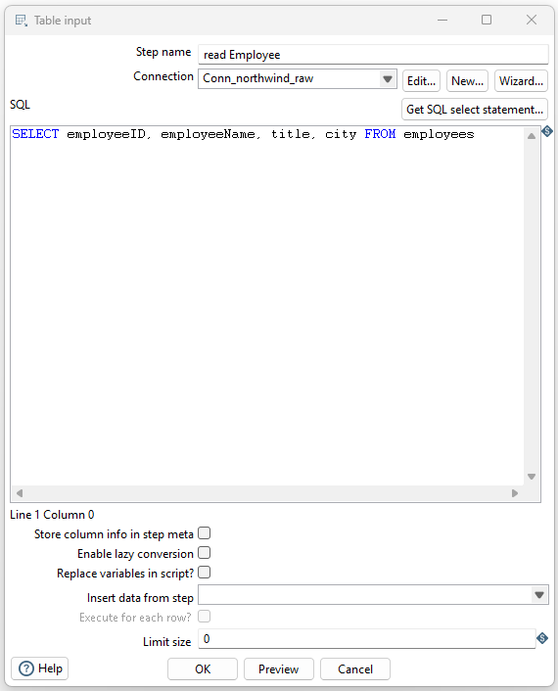

Select values
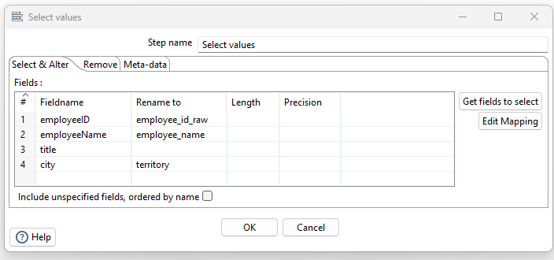

Load dim_employee
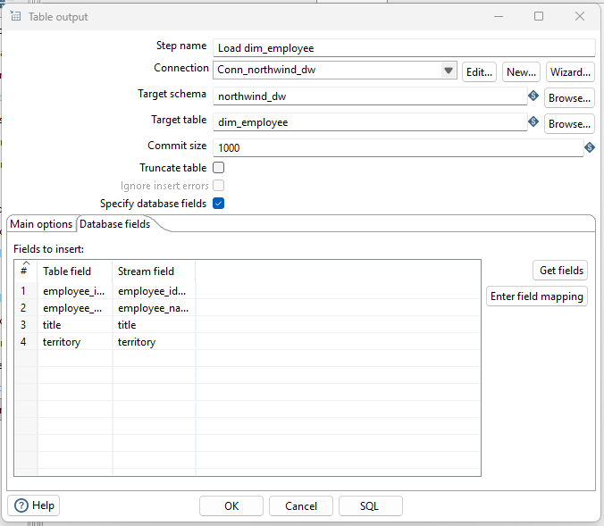

5.2.2 ETL_Customers
Table input
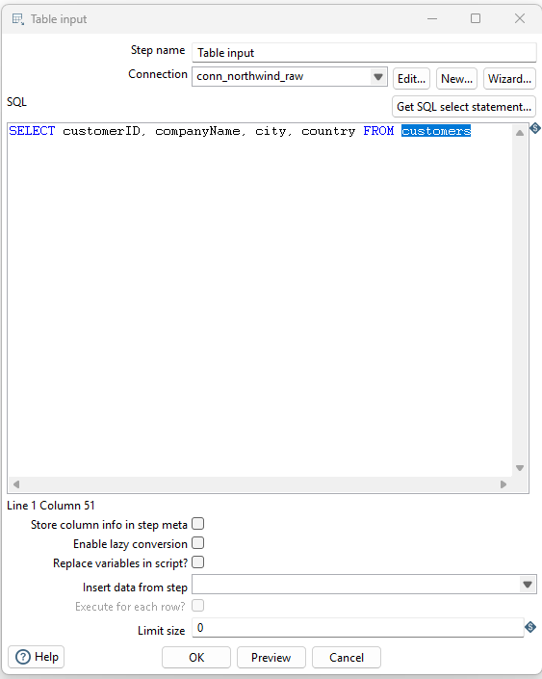

Select values
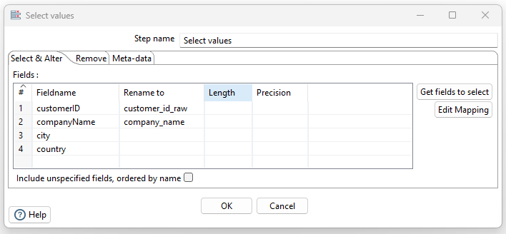

Table output
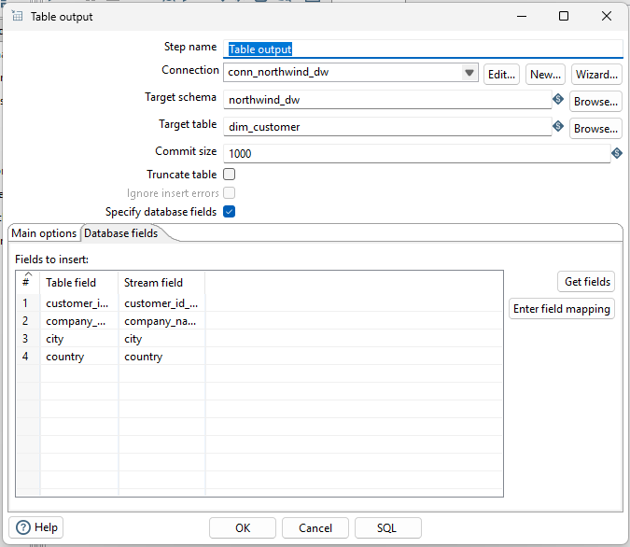

5.2.3 ETL_Categories

Table input
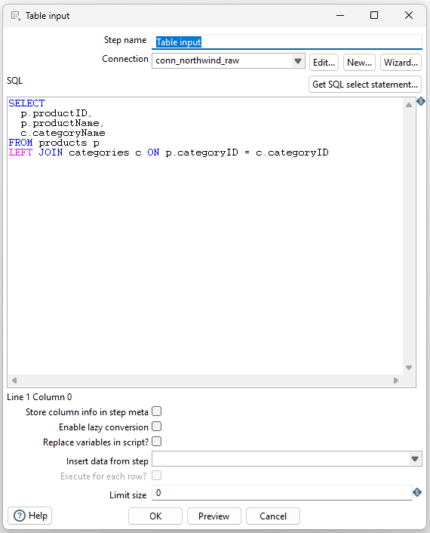

Select values
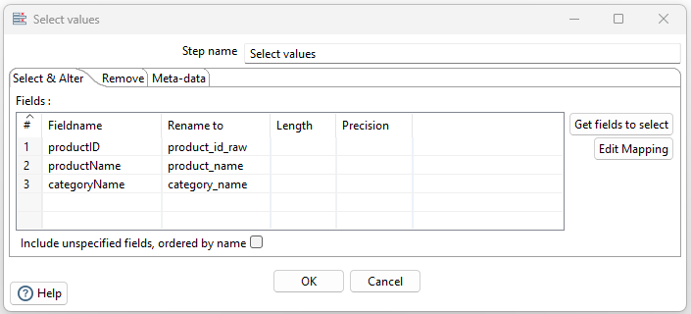

Table output
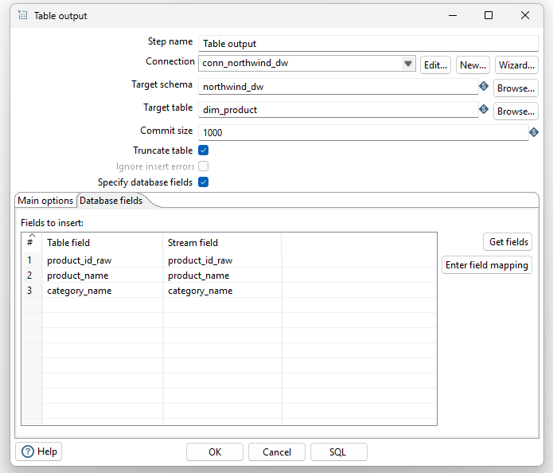

5.2.4 ETL_Date

Table input
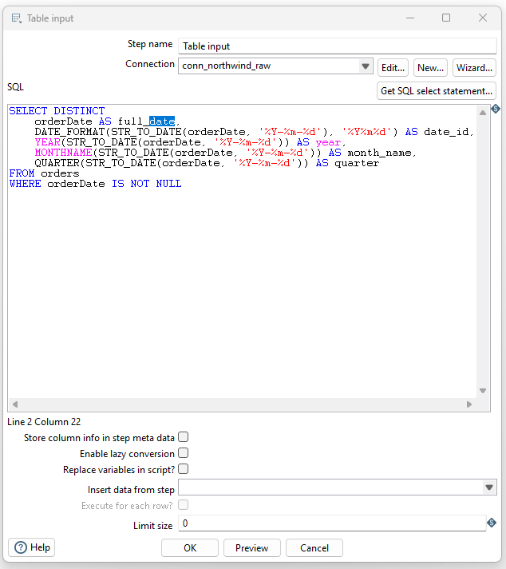

Select values
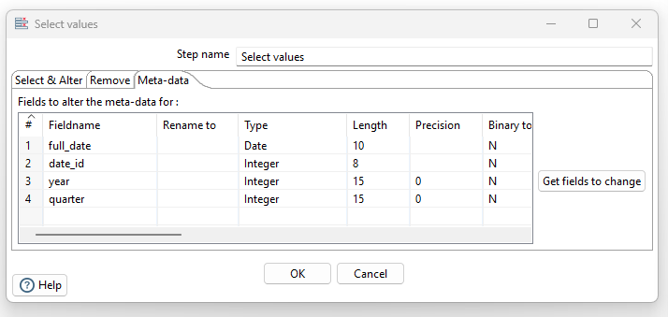

Table output
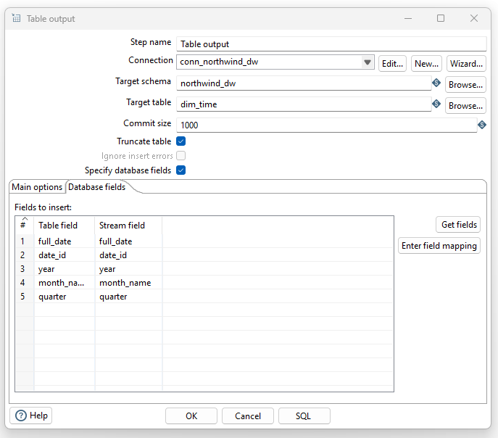

5.3 Implementation of Fact Transformation
Table input
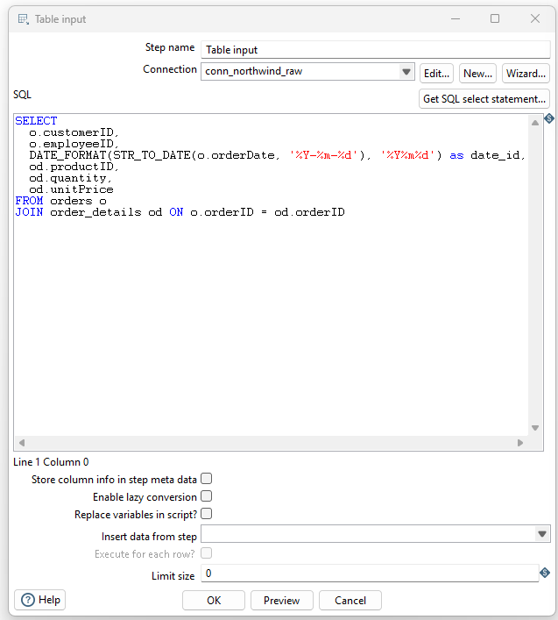

Database lookup customer
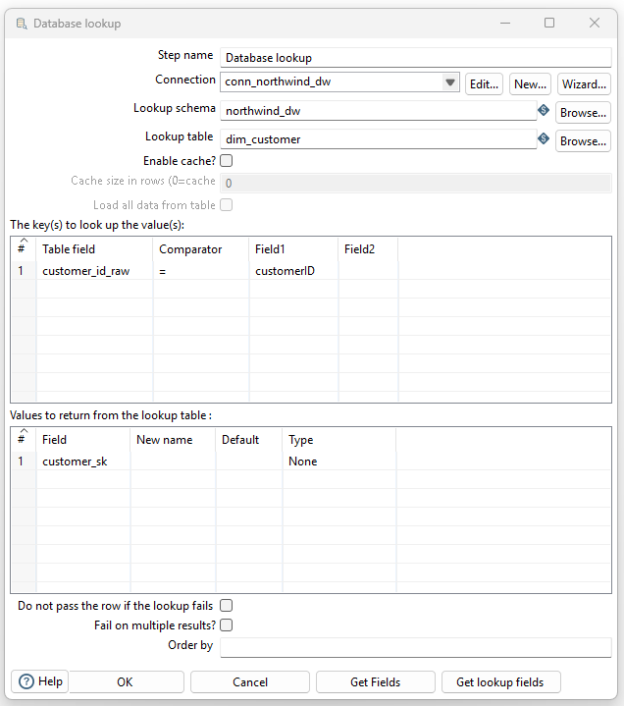

Database lookup employee
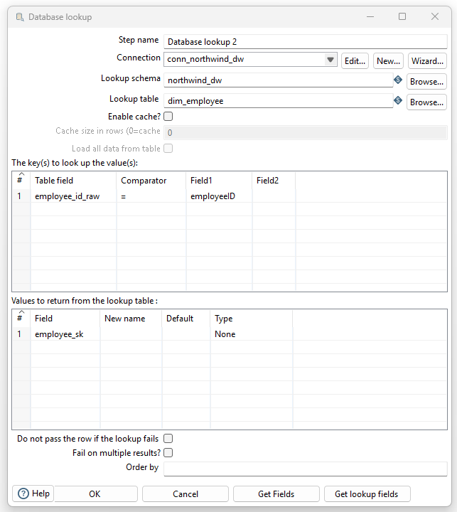

Database lookup product
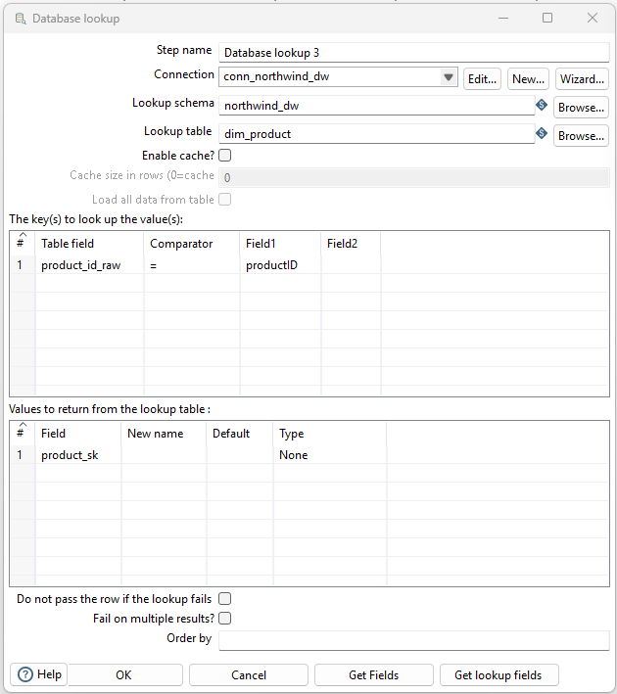

Calculator
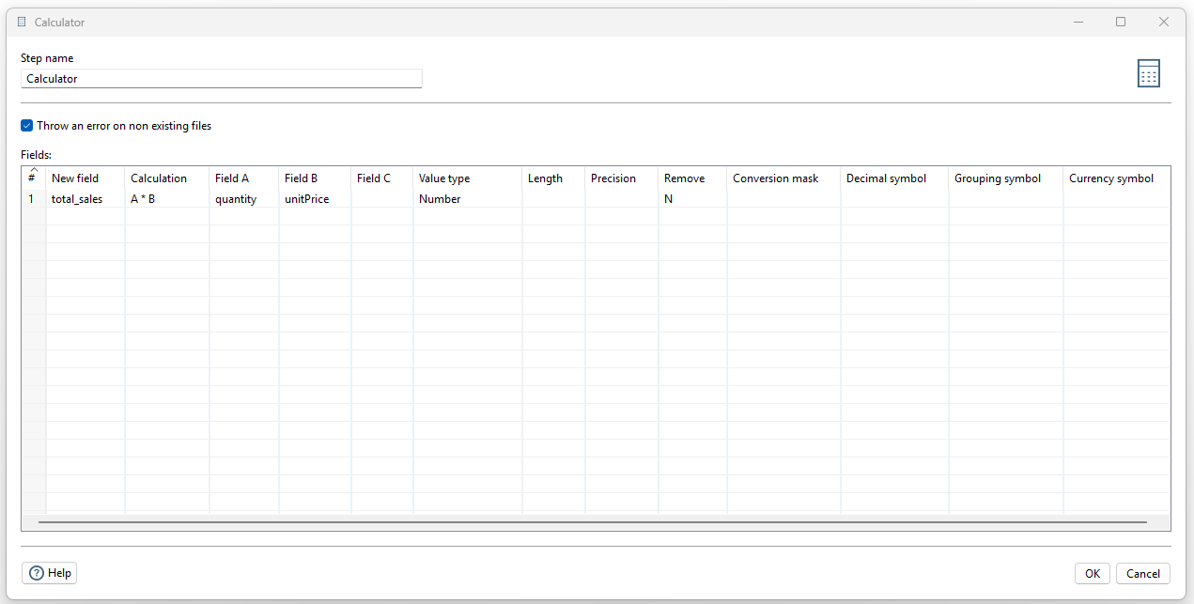
Table output
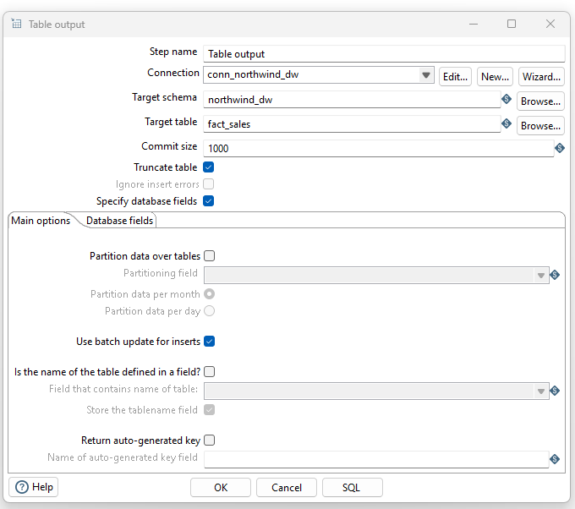

5.4 ETL and Main Job Execution
dimemployees
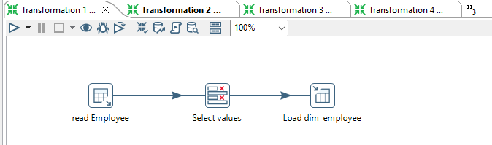
dimcustomers
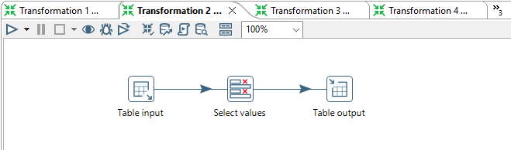
dimcategory
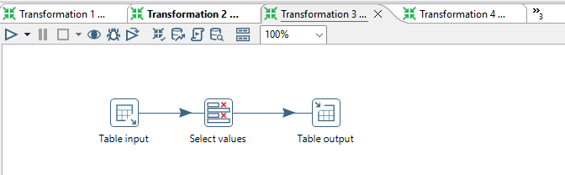
dimdate
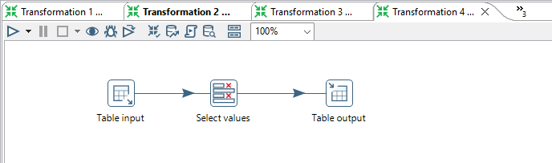

factsales
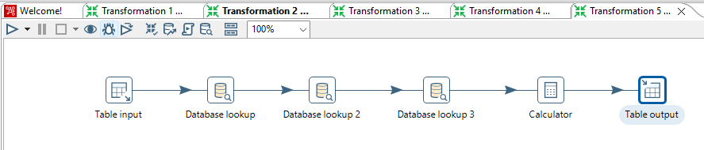

5.5 Results and Validation
Based on the implementation and testing conducted:

- Validation of Dimension & Fact Transformations: All individual transformations (specifically the .ktr files such as Transformation 1 uas.ktr [Dim Employee], Transformation 2 uas.ktr [Dim Customer], Transformation 3 uas.ktr [Dim Product], etc., and Transformation 5 uas.ktr [Fact Sales]) have been successfully executed individually and their results verified. This confirms that the dimension data in the Data Warehouse is populated and valid .
- Main Job Validation: The main job (Job uas finish.kjb), which orchestrates the entire process, has also been successfully executed end-to-end. This proves that the loading sequence (Dimensions loaded before Facts) functions according to the design

CHAPTER 6

ANALYSIS AND VISUALIZATION

6.1 Final Data Warehouse

6.1.1 Dimension Table

customer table
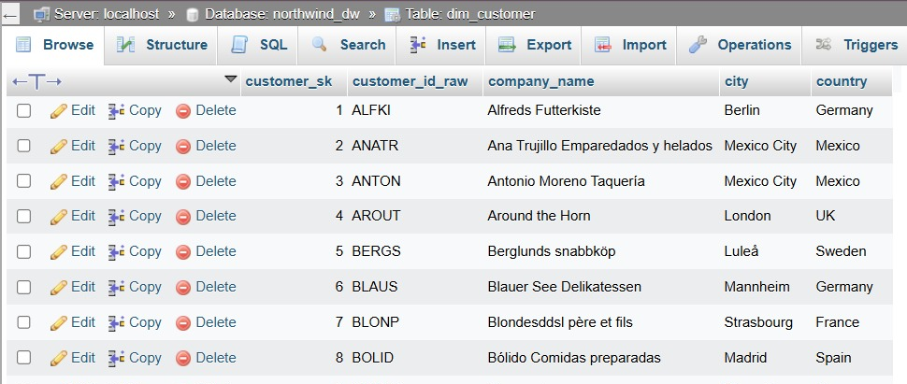

Employee
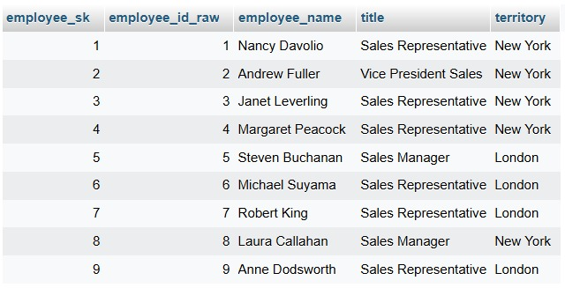

product table
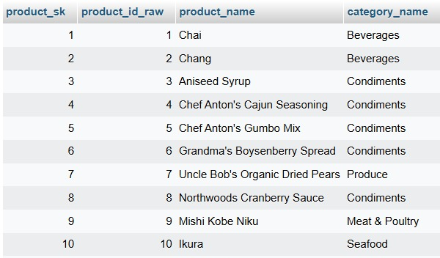

Date table
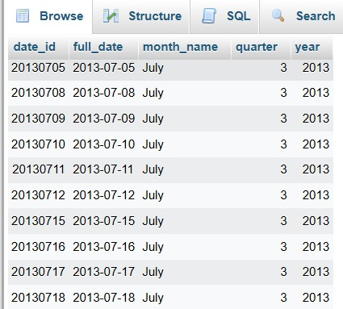

6.1.2 Fact Tables

Fact of Sales
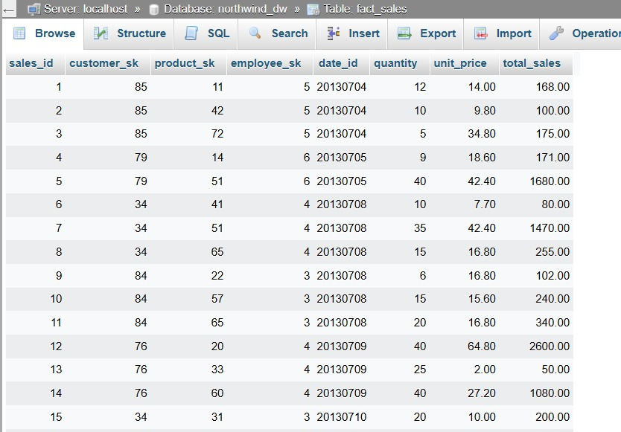

6.2 Sample Queries
This section defines and presents the formulas and SQL implementations for the key metrics that will be analyzed in the Northwind Traders project.

Case Study 1: Calculating Total Sales by Customer Country
Objective: To analyze geographic revenue distribution and identify the most profitable markets.

Query:
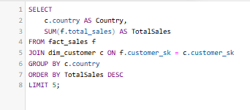

Result :
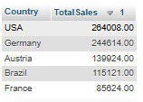
Case Study 2: Analyzing Top 5 Best Selling Products
Objective: To identify products with the highest sales volume (quantity) for inventory management purposes.
Query:
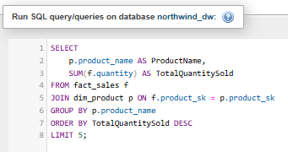
Result:
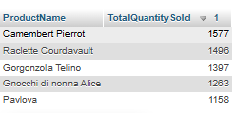

Case Study 3: Sales Segmentation by Product Category
Objective: To determine which product category contributes the most to the company's total revenue.
Query:
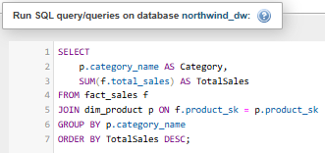
Result :
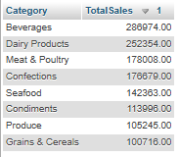

6.3 KPI Calculation
This section defines and presents the formulas and SQL implementations for the key metrics that will be analyzed in the Northwind Traders project.
KPI | Definition | Formula / Calculation | Columns Involved (Schema)
Total Sales | The total revenue generated from all product sales. | SUM(total_sales) | fact_sales.total_sales
Total Quantity Sold | The total number of product units sold to customers. | SUM(quantity) | fact_sales.quantity
Average Transaction Value | The average revenue value per sales line item transaction. | AVG(total_sales) | fact_sales.total_sales
Active Customers | The count of unique customers who have successfully made a transaction. | COUNT(DISTINCT customer_sk) | fact_sales.customer_sk

Combined SQL Query (All KPIs in One Query)
The following SQL query calculates all the Key Performance Indicators defined above directly from the Data Warehouse fact table.
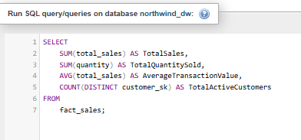

Result :
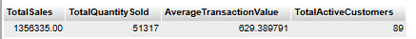

6.4 Dashboard Visualization

6.4.1 Sales Overview
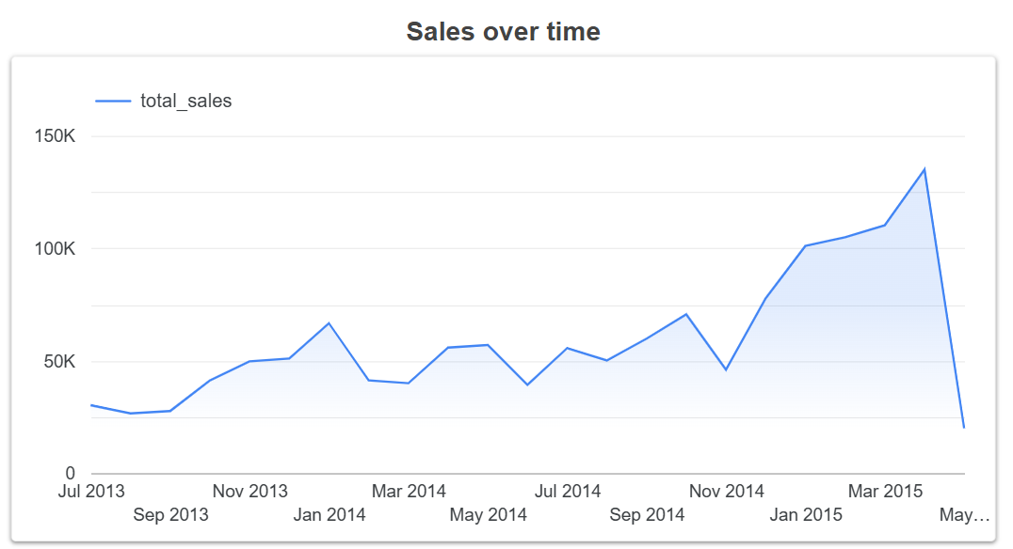
The sales trend over time shows a generally increasing pattern from mid‑2013 to early 2015, with some normal month‑to‑month fluctuations. In 2014 the sales level is already higher than in 2013, and during 2015 there is a clear acceleration, indicating stronger growth.

Several visible spikes appear in specific months, and the largest peak occurs around early 2015, suggesting a period of very high demand. After that peak there is a short drop, which may indicate the end of a promotion period or a seasonal effect in customer purchases.

6.4.2 Top Products & Category Performance

Top 5 Product sales
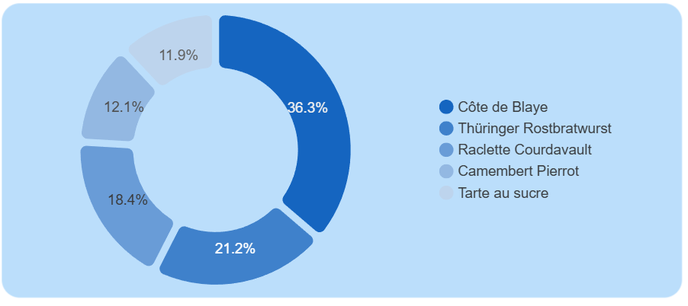
The largest share of sales comes from Côte de Blaye, contributing around one‑third of total product revenue, followed by Thüringer Rostbratwurst and Raclette Courdavault. This indicates that a small group of premium products drives most of the income, so they should be prioritized for inventory, pricing strategy, and promotion

Top 5 Customer Names
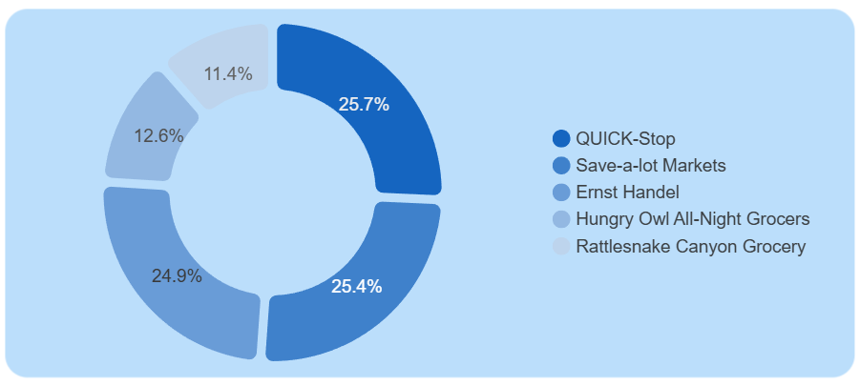
QUICK‑Stop and Save‑a‑lot Markets are the two biggest customers, together generating more than half of sales among the top accounts. These key customers represent high business value, so maintaining service quality and long‑term relationships with them is critical while still developing the other strategic customers.

Quantity and sales by product
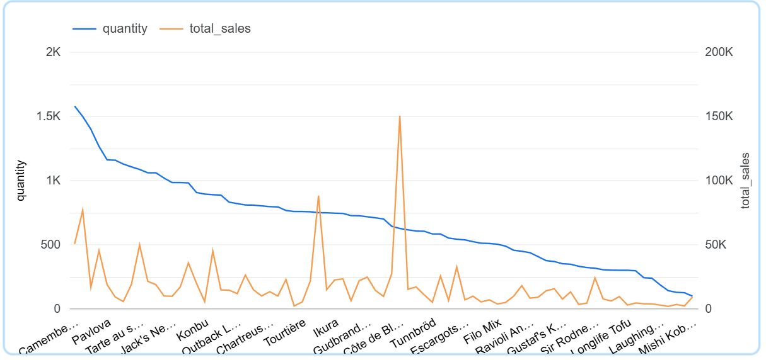
The chart compares quantity sold and total sales for each product, sorted from the highest to the lowest quantity. The blue line shows that a small number of products contribute very large volumes, while many other products have only low to medium quantities.

The orange spikes indicate products where the revenue is high compared to their quantity, which means these products have a higher unit price or margin. Together, this pattern shows which items are high‑volume drivers and which are premium products that generate strong sales even with lower quantities

Top products by quantity
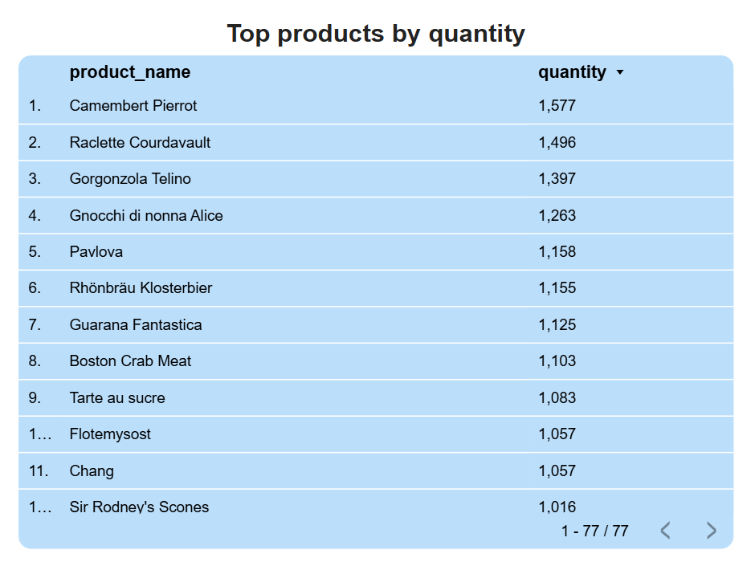

Top 10 products by total sales
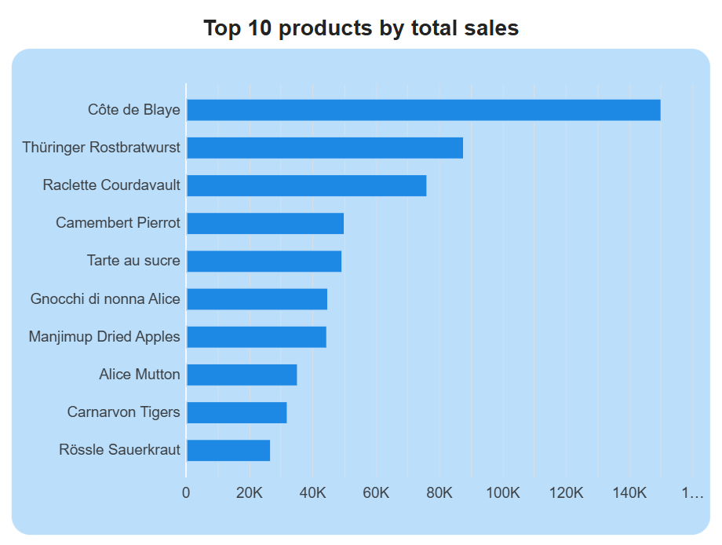

6.4.3 Product portfolio: volume vs revenue
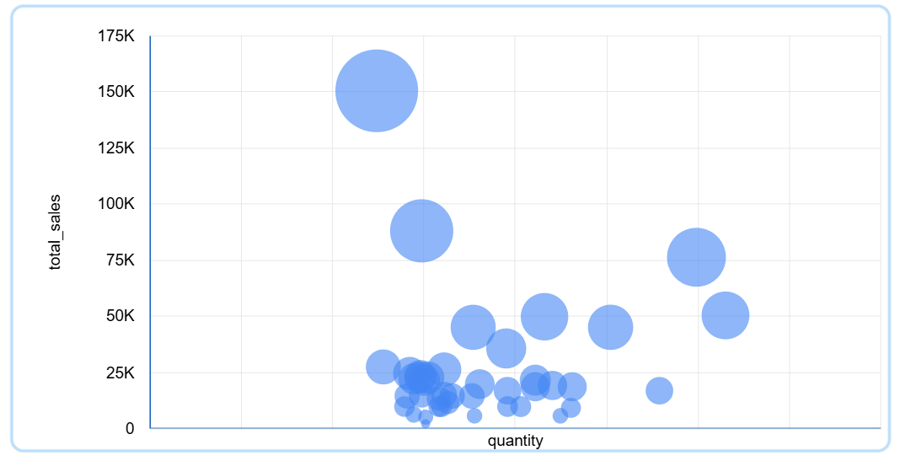
The bubble chart plots 40 products by quantity and total sales. Côte de Blaye appears as the largest and highest bubble, meaning it combines very strong revenue with relatively high volume, while Geitost sits at the bottom with much lower sales and quantity, showing it is a minor product in the overall portfolio.

6.5 Analysis of Findings
Based on the Data Warehouse implementation and the visualization results, the following key findings were identified:
- Market Dominance: The analysis reveals that the USA and Germany are the most critical markets for Northwind Traders, contributing over 37% of the total global revenue. This suggests that marketing strategies should prioritize retention in these regions while exploring expansion opportunities in underperforming regions like Southern Europe (Italy/Spain) or parts of South America.
- Product Portfolio Strength: Beverages and Dairy Products are the core revenue drivers. Specifically, high-volume, lower-cost items (like Rhönbräu Klosterbier) and premium cheese products (like Camembert Pierrot) show the highest turnover rates. Conversely, the Produce and Grains categories show slower movement, indicating a potential need for promotional discounts or inventory re-evaluation.
- Sales Seasonality: The temporal analysis via dim_time indicates a clear seasonality in sales, with peaks occurring in the months leading up to the end of the year. This pattern aligns with typical retail behavior and suggests that Northwind Traders should ensure higher inventory levels in Q3 and Q4 to meet the anticipated demand surge.
- Operational Efficiency: The successful load of 2,155 fact records with zero integrity errors confirms that the ETL pipeline is robust. The ability to calculate the "Average Transaction Value" ($628) allows the sales team to set concrete targets for upselling strategies in the future.

CHAPTER 7
CONCLUSION AND SUGGESTIONS

7.1 Conclusion
Based on the design, implementation, and analysis conducted throughout this project, the following conclusions can be drawn:

- Successful Data Warehouse Design:
The project successfully designed a Star Schema for Northwind Traders, consisting of one fact table (fact_sales) and four supporting dimension tables (dim_customer, dim_product, dim_employee, and dim_time). This structure effectively denormalizes the complex transactional data into a format optimized for analytical queries .
- Effective ETL Implementation:
The Extract, Transform, Load (ETL) pipeline, built using Pentaho Data Integration (PDI), successfully integrated raw data from multiple CSV files. The process handled data cleaning, transformation of data types, and the generation of surrogate keys, ensuring that only clean and consistent data was loaded into the target MySQL Data Warehouse .
- Business Insight Capability:
The implementation allows for the rapid calculation of critical Key Performance Indicators (KPIs). The system can now answer strategic business questions—such as identifying the Top 5 Best-Selling Products or analyzing Revenue by Country—which previously required complex joins on the operational system.
- Data Integrity Maintenance:
The loading strategy, which prioritized dimension tables before the fact table, successfully maintained referential integrity. The use of Surrogate Keys (_sk) isolates the analytical environment from potential changes in the source system's primary keys.

7.2 Suggestions
To further enhance the capabilities and robustness of the Northwind Traders Data Warehouse, the following improvements are suggested for future development:

- Implementation of Slowly Changing Dimensions (SCD):
Currently, the system overwrites dimension data (SCD Type 1). It is recommended to implement SCD Type 2 for the dim_customer and dim_product tables to track historical changes (e.g., if a customer moves to a different region, the historical sales data remains associated with the old region).

- Dashboard Integration:
While the Data Warehouse is functional, the current analysis relies on SQL queries. Integrating the database with a visualization tool like Microsoft Power BI or Tableau would provide interactive, real-time dashboards for non-technical stakeholders.

- Automated Scheduling:
The current ETL process is triggered manually. Utilizing an external scheduler (like Windows Task Scheduler or Cron) to execute the Pentaho Job (.kjb) automatically on a nightly basis would ensure the data remains up-to-date without manual intervention.

- Scope Expansion:
The current scope focuses solely on Sales. Future iterations should expand the Star Schema to include other business processes, such as Inventory Management (Fact Inventory) or Purchasing (Fact Purchase), to provide a holistic view of the company's supply chain performance

